**The State Executive Branch Notes**

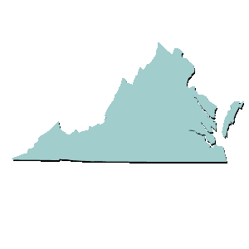



**The State Executive is the Governor and has many roles and**

**jobs within the government just like the President.**

|  |  |  |  |
| --- | --- | --- | --- |
| **Role in the Government** | **What does that mean?** | **Examples** | **Logo**  **Design a logo** |
| **Chief of State** | **Ceremonial Head of Virginia Government** |  |  |
| **Chief Legislator** | **Proposer of the Virginia legislative agenda** |  |  |
| **Chief Administrator** | **Leader of the agencies that make up the executive branch in Virginia** |  |  |
| **Chief of Party** | **Leader of the political party that controls the Executive Branch in the state** |  |  |
| **Commander-in chief** | **Leader of the Virginia National Guard** |  |  |

**The state executive branch including the cabinet, executive agencies, commissions, and regulatory boards carry out the laws in Virginia when they…**

|  |  |  |
| --- | --- | --- |
| **Executive act** | **What does that mean** | **Example** |
| **Administer and enforce laws** |  |  |
| **Regulate aspects of business and the economy** |  |  |
| **Provide services** |  |  |