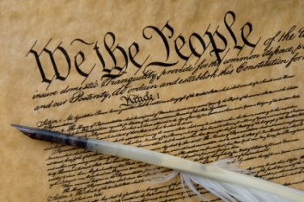

The structure and jurisdiction of the United States court system is found in _____________________________ of the US Constitution and federal laws.

**What phrase in the Preamble states that the Constitution will

have an organized court system?_______________________________________

The United States has a DUAL COURT SYSTEM:

**The Supreme Court** has the FINAL appellate jurisdiction (if necessary)

**Federal Courts** hear cases related to national laws

**State Courts** hear cases related to state laws

The Federal Court System

In order to have your case tried in the National Court System, you must have committed a crime in more than one state, have a dispute involving commerce or federal taxes, violated a copyright law (illegally downloading music), committed a crime involving the US Post Office (stealing mail), have an issue involving a foreign country, issues involving the US Constitution, or if there is a dispute between states.

**US Supreme Court** – Cases heard by ____________________

* _____________________

Has appellate jurisdiction over:

* _________________________________
* _________________________________

Has limited _______________________ jurisdiction

**US Court of Appeals** – Cases heard by ____________________

* _____________________

Has appellate jurisdiction over:

* _________________________________

**US District Court** – Cases heard by ____________________

* _____________________________________

Has original jurisdiction over:

* _________________________________

Start