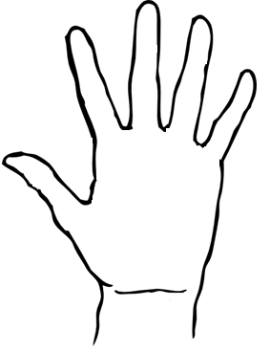

**The Helping Hand!**

The model citizen has traits and responsibilities that make them unique. To create your helping hand, please follow the directions below step by step. Please be neat and use color!!

__Step 1: Label each finger with the following:

__Thumb: A trait of a good citizen

__Index Finger: A way to participate in civic life

__Middle Finger: The two ways to become a US citizen

__Ring Finger: A ***duty*** of a citizen

__Pinky Finger: A ***responsibility*** of a good citizen

__Step 2: On the hand, below each finger create an illustration of each of these traits in action.

*Hint: Use some of the ***responsibilities*** of citizens in your drawings:

Step 3: Color and make it fabulous!

In all, you should have 5 traits and 5 illustrations, each representing one of those traits. Great job, outstanding citizen!