**CE.5d The high cost of getting elected – Campaign Finance Notes**

- Campaign = running for office

- Finance = funding

**Question:**

How has the high cost of getting elected changed running for office?

**Players:**

**Interest Groups:** group of people that believe in one issue

* give $$$ to politicians running for office
  + politicians may vote for the interest group’s concerns **not** for the people’s interest
* **Lobbyists:** an interest group employee that persuades politicians
  + - give $$$, favors

**PACs: Political Action Committees**

* a **group** of interest groups & wealthy people, bundled contributions
* limited contributions to political parties and candidates

**Super PACs:**

* **2010 Supreme Court Decision – limiting political spending is unconstitutional – (Citizen’s United vs FEC)**
* **Unlimited spending**
* **Unlimited donors**
* **Cannot contribute directly to political parties or political campaigns**

**Result** - Campaign Costs are rising every year

* limits opportunities to run:
  + - Who can run for office:

Only Rich

People picked by the rich

* + Fund-raising is impacting office holders and those seeking office
    - Politicians spend time fundraising **NOT** fixing problems

**Who can fix this?**

* Lawmakers? getting the $$$
  + No $$$ can’t get elected, lose their job

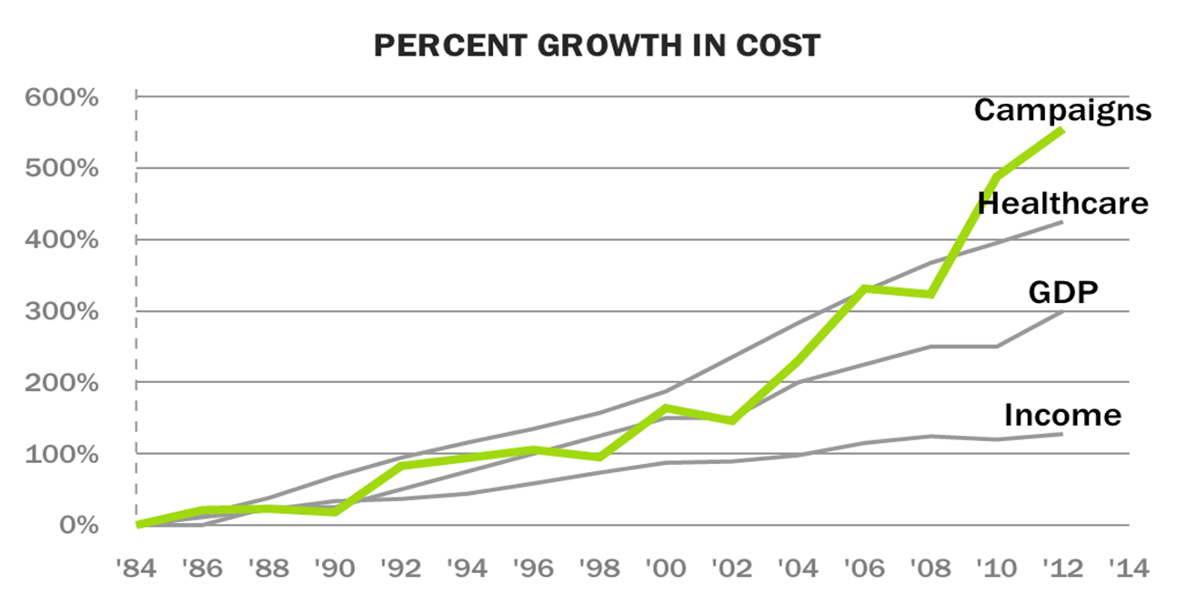

Presidential Campaign spending

1976 - 67 million

1988 – 210 million

2000 - 343 million

2012 – 2.1 billion

