What is the Local Level of Government?
Local Government Worksheet

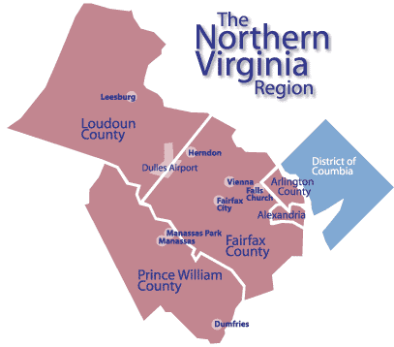
What is the local government in charge of?
*_____________________________________________________
How does the local government get its power?
*All powers of local governments in Virginia are given to them by

__________________________________________________________

*Are all counties and cities given the same powers? ____

*Cities list their powers in the _____________. _________________________________________

What are the powers of Local Governments?
Local government exercises defined and limited powers, including… | Illustrate an Example of this Power
*Enforce State and local Laws, which means…

*Promote Public Health, which means…

*Protect Public Safety, which means…

*Educate Children, which means…

*Protect the Environment, which means…

*Regulate Land Use, which means…

*Levy and Collect Taxes, which means…

