What is Federalism?

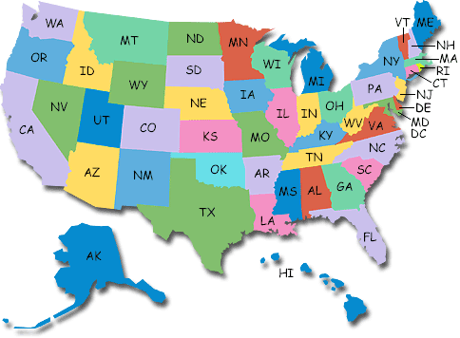
___ ________ Level

Federalism Notes
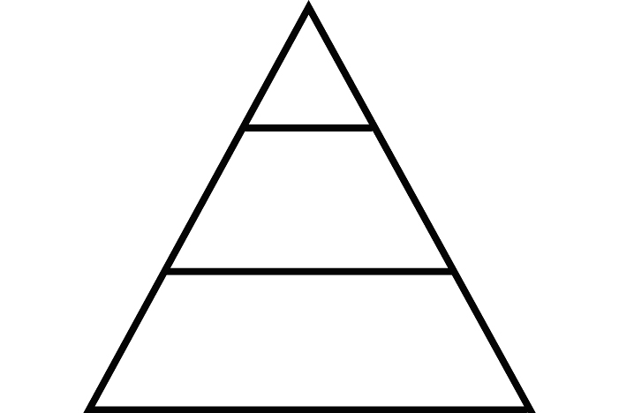
___ _____________ Level

1

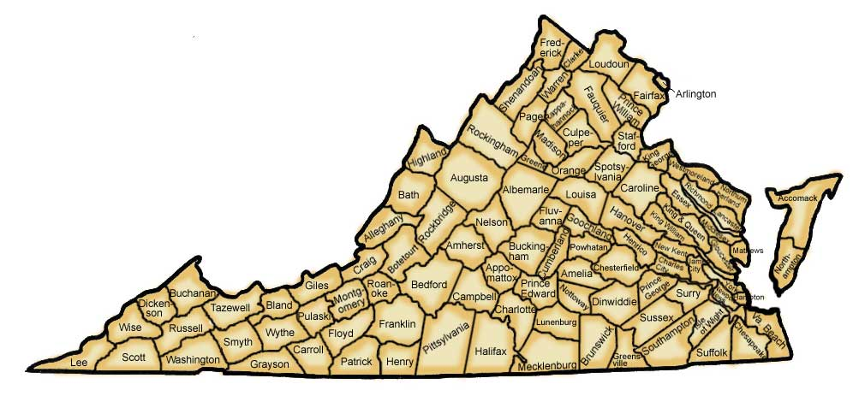
50

____ _________ Level

48,878

How is power divided and shared among the levels of Government?
Responsibilities of the  NATIONAL Government | Responsibilities of the  STATE Government
- Conducts policy –  __________________________________  __________________________________  - Regulates –  __________________________________  __________________________________  - Provides for the –  __________________________________  __________________________________ | - Promotes –  __________________________________  __________________________________  - Promotes –  __________________________________  __________________________________  - Promotes –  __________________________________  __________________________________

