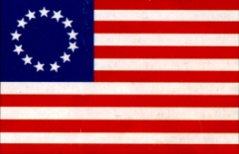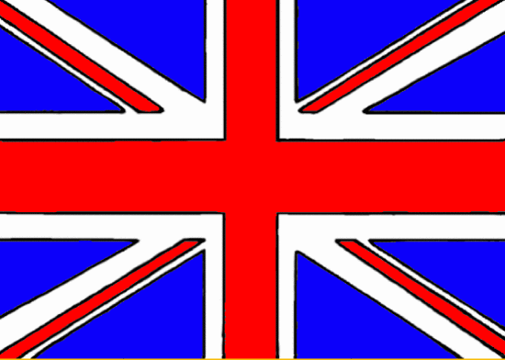**The Path to Independence and a New American Government**

In 1776, American colonies, having finally tired of the tyranny of British rule, began making strides to declare independence from Great Britain and creating their own government. Virginia led the way, creating the Declaration of Rights, which listed the basic fundamental rights of people. These ideas were later incorporated into the Bill of Rights and were drawn upon by Thomas Jefferson when he authored the Declaration of Independence. Following soon thereafter, Thomas Jefferson continued the distancing from British rule by establishing a separation of church and state and freedom of religion (Britain had a national religion and church); two ideals that were also included in our current Constitution.

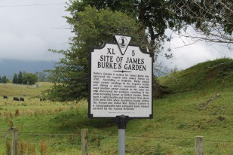[](http://www.google.com/imgres?imgurl=http://www.thatcherbrook.com/images/specials/july4th.gif&imgrefurl=http://www.thatcherbrook.com/4th-of-july-vacation-in-vermont.htm&usg=__nYJAoBjWeusKOHUITGsuaL5-jM4=&h=307&w=267&sz=7&hl=en&start=26&zoom=1&um=1&itbs=1&tbnid=g91dkBF26wYlPM:&tbnh=117&tbnw=102&prev=/images?q=4th+of+july&start=20&um=1&hl=en&safe=active&sa=N&rls=com.microsoft:*&ndsp=20&tbs=isch:1)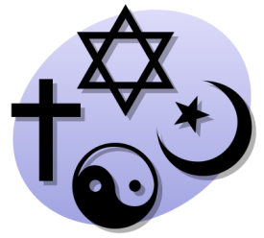

Date Written:

Author:

Importance:

Date Written:

Author:

Importance:

Importance:

Date Written:

Author:

Virginia Declaration of Rights

Virginia Statute for Religious Freedom

Declaration of Independence