**The National Legislative Branch:**

Congress is a BICAMERAL legislature, which means it has ___ ___________________.

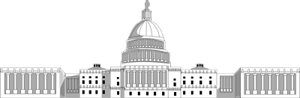

**THE LEGISLATIVE POWERS**

Congress’s powers are found in Some of these listed powers are:

________________________________ ____. 1. Makes ________of the NATION

The Congress has two types of powers: 2. APPROVES the annual ________

1. expressed powers=______________ 3. _______ presidential appointments

1. 2. implied powers=________________ 4.RAISES revenue through _____ and levies

5.__________ interstate and foreign trade

6. Declares ______

***House of Representatives:***

***___***Members, based on _________ of the _______.

***Senate:***

__ Senators per state = ____ total Senators

**THE LEGISLATIVE POWERS**

**_______________________________** are specifically listed.

**_______________________________** are used to carry out expressed powers.