The Local Legislative Branch  Structure of Local Government Notes  Who is the local legislative branch?  For a county:___________________________ For a Town or City:_____________  What are their primary jobs? | Richmond City Council  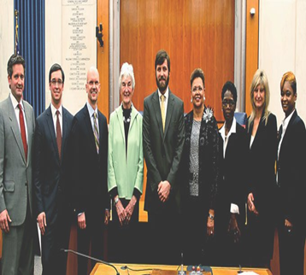
The Local Executive Branch  *Who is the local executive branch?  For a county:___________________________ For a Town or City:_____________  *What are their primary jobs? | Mayor Jones Richmond Va  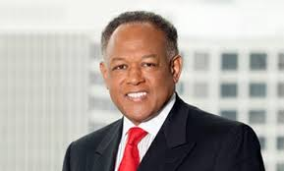
The Local Judicial Branch  *Who is the local judicial branch?  For a counties, cities, and towns:________________________________________  *What are their primary jobs? | Richmond City Hall  

Other Parts of Local Government
* School Board
What do they do? ___________________________________________________

Does every local government have one? _________________________________

How are they chosen? _______________________________________________
*Manager
What do they do? ___________________________________________________

Does every local government have one? _________________________________

How are they chosen? _______________________________________________
*Other Elected Officials -
What do they do? ___________________________________________________

Does every local government have one? _________________________________

How are they chosen? _______________________________________________
Individuals can have the greatest influence on the decisions made by local government officials. Why is this true?

