CE 7c: State Law Making Process

Like the National Governments Congress, the State of Virginia has a *General Assembly.* Citizens of the state elect other citizens to make laws for the state.

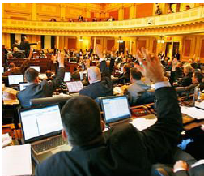

* The lawmaking process in the Virginia General Assembly
* Introducing a bill
* Working in committees
* Debating the bill on the floor of each house
* Voting on the bill in each house
* Sending the bill to the governor to sign into law

Laws are made as a response to issues and/or problems in the state. Lawmakers then take the issue and use the 5 step process above to create a law.

The primary issues in the legislative process at the state level

• Education: To promote an informed and engaged citizenry (i.e., establish minimum standards for local schools)

• Public health: To promote and protect the health of its citizens (i.e., fund health benefits)

• Environment: To protect natural resources (i.e., improve water quality in the Chesapeake Bay)

• State budget: To approve a biennial (two year) budget prepared by the governor

• Revenue: To levy and collect taxes

What do you know?

1. Which of these is not a primary issue of state lawmaking?
2. State budget b) education c) military d) public health
3. The state General Assembly is the same as the national?
4. Congress b)courts c) president d) lawyers
5. State laws are made as a response to?
6. Doing favors for business c) what sounds good
7. Problems and issues d)a presidential request