**9/17 Warmup**

**Name**

**Date**

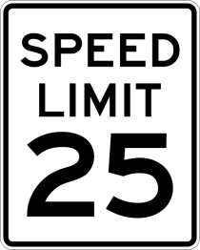**\*What are things US citizens MUST do or they will get in trouble with the law?**

* Actions that citizens MUST do are called:_________________________________________
  + These include:

Citizens who do not perform these actions face ______________________________________

**\*What are things US citizens should volunteer to do?**

* Actions that citizens SHOULD do are called:_________________________________________
  + These include:
* Individuals demonstrate responsible citizenship by performing _____________________
  + Example:

**9/21 Warm-up**

**We are studying US Citizenship:**

**1. Define – duty of US citizenship -**

**2. Define – responsibility of US citizenship –**

**3. Define – right of US citizenship -**