Federalism is like a Marble Cake!

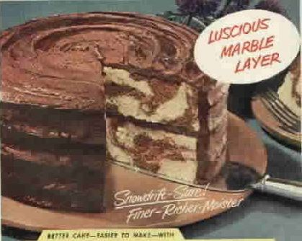
- What does a Marble Cake look like?

- What is Federalism?

- How is a Marble Cake like federalism?

- What would the two flavors represent?

State Power or National Power?
For each of the situations listed below, decide who would exercise power in this situation, National or State.

- Declares war __________________________________________

- Conducts trade with China __________________________________________

- Administers flu vaccines to senior citizens __________________________________________

- Manages the army __________________________________________

- Managers homeless shelters __________________________________________

- Oversees police and fire departments __________________________________________

- Oversees emergency medical personnel __________________________________________

Federalism at Work in Our Government

Governmental Process | Explain the Process | Local | State | National
Amendment Process | Step 1)  Step 2)

How does is the Amendment Process an example of Federalism at work in our government?

