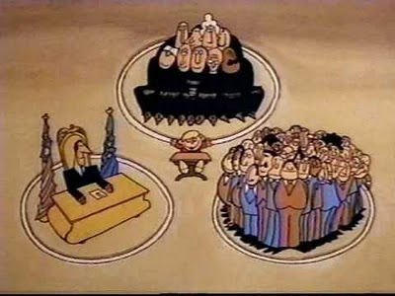
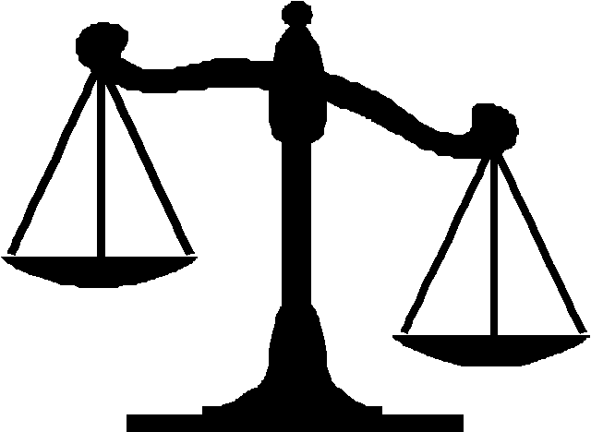
Checks and Balances Practice
Part One: In the School House Rock Video, they compared Checks and Balances between the three branches to a three ring circus. Illustrate your own metaphor for Checks and Balances in the box below.

Part Two: What are the key words for each of the branches that you will be looking for in the answer choices? Then, answer the questions below.

Legislative Branch:___________________________________________________________________
Executive Branch: ___________________________________________________________________
Judicial Branch: _____________________________________________________________________
- Which of the following is an Executive Branch check on the Legislative Branch?
  - Approves Presidential cabinet appointments
  - Impeach senators
  - Approves budget
  - Appoints

- Which of the following is a Judicial Branch check on the Legislative Branch?
  - Declare executive order unconstitutional
  - Impeach a President
  - Impeach federal judges
  - Declare laws unconstitutional

- Which of the following is a Legislative Branch check on the Executive Branch?
  - Appoint Senators
  - Override a veto
  - Declare Executive Orders unconstitutional
  - Impeach federal judges

- Which of the following is an Executive Branch check on the Judicial Branch?
  - Impeach federal judges
  - Appoint federal judges
  - Approve federal judge appointments
  - Declare laws unconstitutional

- Which level and branch of government approves a biennial budget?
  - National Executive
  - State Legislative
  - National Legislative
  - Local Legislative

