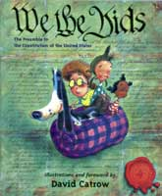Create your own Preamble Cartoon. Just like the author of the book “We the Kids,” you will create seven illustrations that show the seven goals of the Constitution!

|  |  |
| --- | --- |
| We the people… | …to form a more perfect union… |
| …to establish justice… | ...to ensure domestic tranquility... |
| ...to provide for the common defense… | …to promote the general welfare… |
| …to secure the blessings of liberty. | |