
CE.10 Judicial Branch Basics
*There are two reasons to go to court:


- A law is broken, which is called a _________________________________________
Example:

- An argument between two people or groups, which is called a ___________________________
Example:

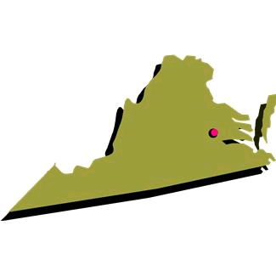
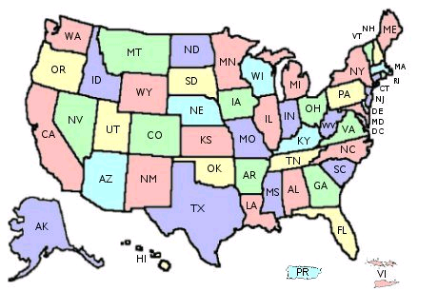
*The court system you go to depends on the location of the broken law or argument:

- If you break a Virginia law or have an argument in Virginia, you go to the _______________________
Example:

- If you break a national law, have an argument in more than one state, or have an argument with

someone in more than one state, you go to the __________________________________________
Example:

- Since there are two types of court systems, the Judicial Branch has a __________ court system

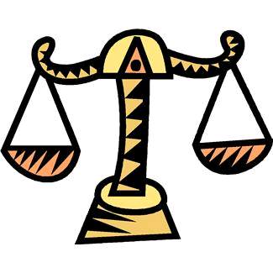
*Individuals have rights in the courts:
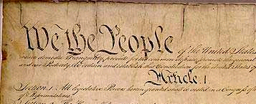

- The Constitution protects you against unfair government actions, which is called __________________

- The two amendments that protect you are the _______ and _______

